**Identifying most common Business to Invest in Mumbai and in which area**

**Data Source**

<https://en.wikipedia.org/wiki/List_of_neighbourhoods_in_Mumbai>

**Methodology**

Using Four Square API to get venues and venues categories of location data scrapped from wiki page. After get the venues most common venues are identified in different location so as to identify the most common venues of different location.

Steps of Analysis:

* Extracting Location from the Wiki Page
* Using Four Square API to Get Venue and Venue Categories
* Merging data from two sources on Latitude and Longitude common in the two Dataframe
* Creating onehot for locations across all venue category
* Taking mean of the venue category across area and location
* Identifying top venues of different location
* Creating 6 Cluster of dataset

Libraries and Packages used are :

* Pandas
* Numpy
* Geopy
* Scikit Learn
* Matplotlib
* BS4
* Folium

**Analysis**

**Mumbai Locations on Map**

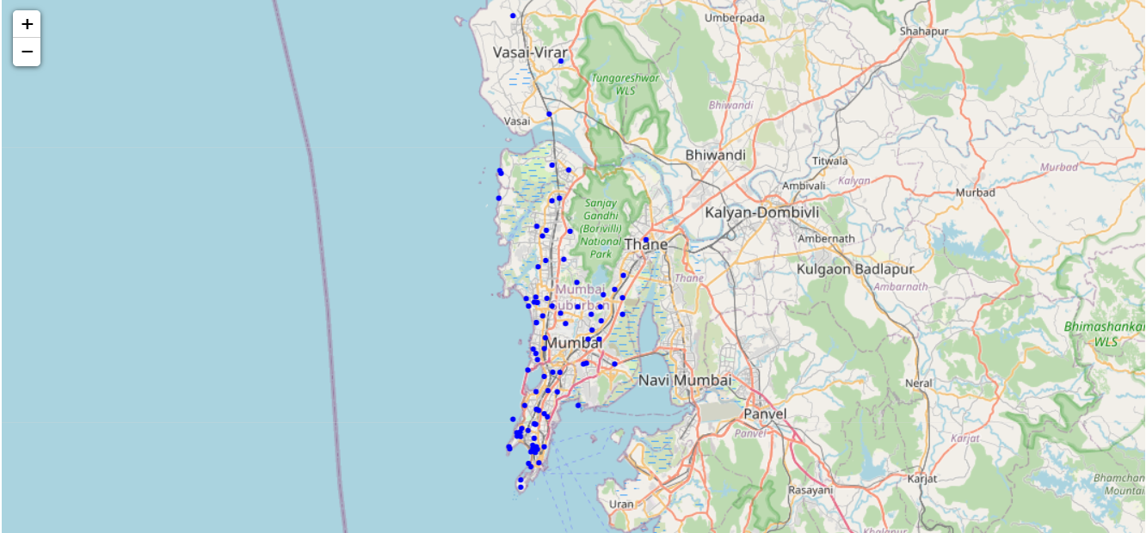

**Number of Venues in Different Location**

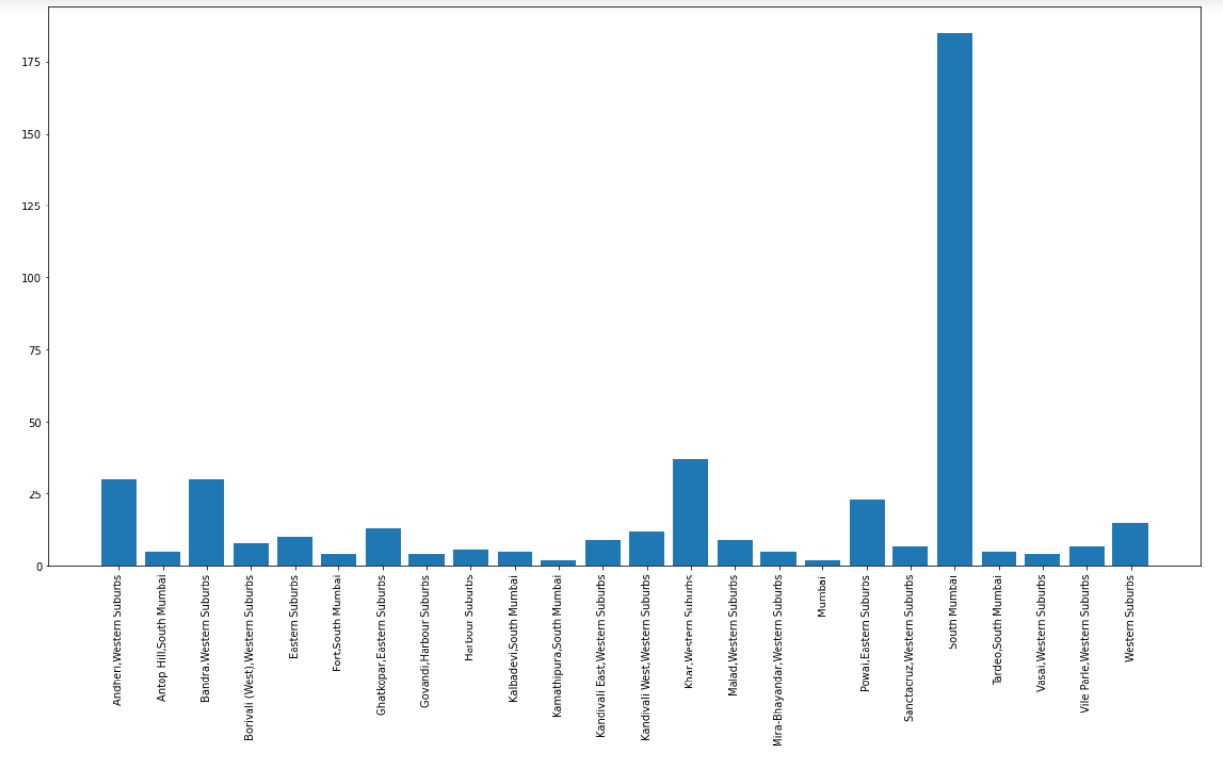**Most Diverse Location**

* **South Mumbai**
* **Andheri Western Suburbs**
* **Bandra West**
* **Khar West**

**Locations Vs Most Common Venues**

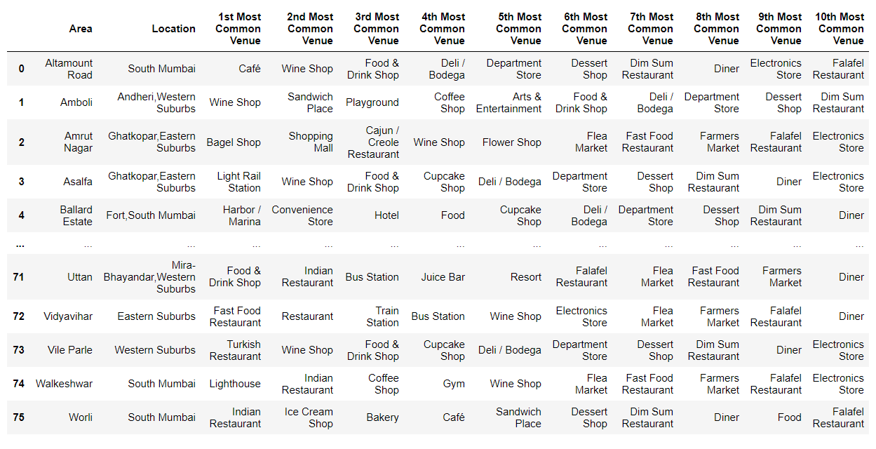

**Most Common Venues**

* **Restaurants,**
* **Cafes,**
* **Wine Shop,**
* **Ice Cream Shop**

**Most Common Venues in Andheri**

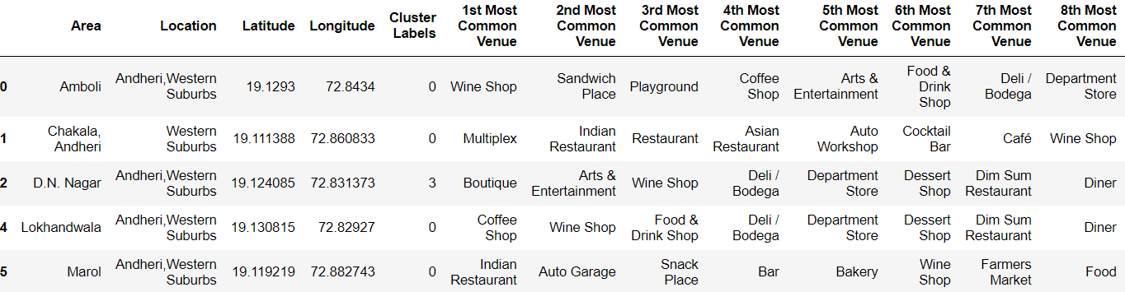

**Most Common Venues in Andheri**

* **Restaurants**
* **Coffee Shop**
* **Eateries**

**Frequency Of First Most Common Venue in Different location**

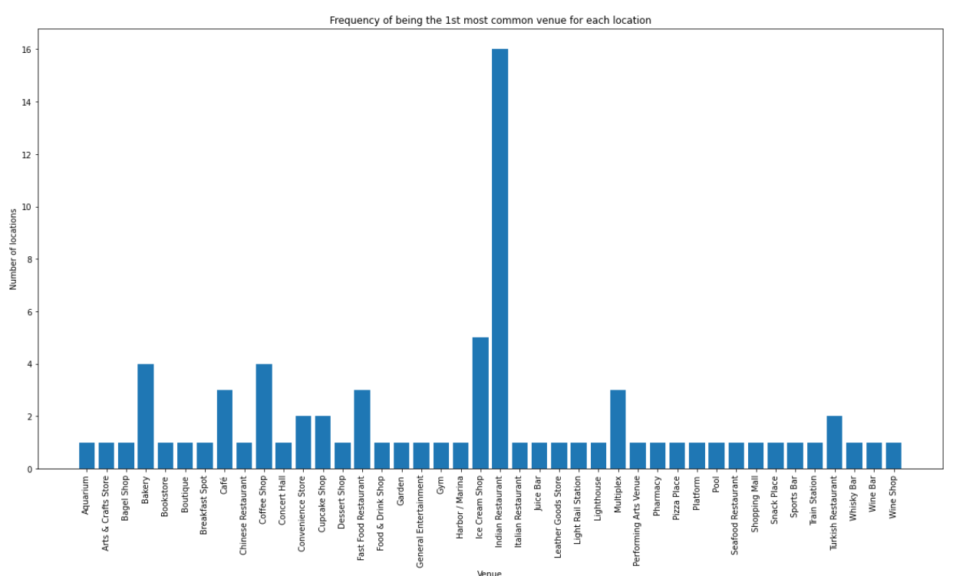

Order of First Most Common Venue Frequency in Mumbai across different location

1. Indian Restaurants
2. Ice Cream Shop
3. Coffee Shop
4. Bakery
5. Cafe

**Result**

After analysis it could be identified Indian Restaurant is the most common venues in most of the areas and few area where it could be opened are Andheri, South Mumbai, Powai etc.

**Discussion**

The data from Four Square API gives an idea of most common venues in different location which can be used to identify business opportunity for an entrepreneur to begin with. After analysis it can be seen most common venues are mostly restaurants, cafes, Ice-cream shops etc. Now the location it can be opened up also depends on the several other factor but to begin with its always better to go with place having restaurants as most common venue.

**Conclusion**

Andheri is the area where Indian restaurants are most common venue so to start a restaurant in the area is good to go idea.